training 1 epoch...

58.83847951889038 seconds used......

1 training finished! average train loss: 0.7112756153862727

evaluating...

Confusion matrix, without normalization

[[ 228 38 28]

[ 874 2859 88]

[ 49 18 775]]

Normalized confusion matrix

[[0.7755102 0.1292517 0.0952381 ]

[0.22873593 0.74823345 0.02303062]

[0.05819477 0.02137767 0.92042755]]

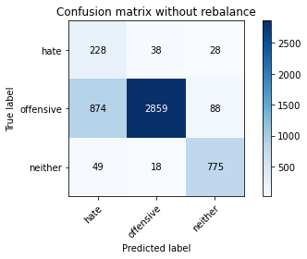

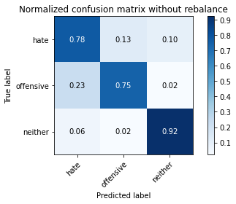

precision recall f1-score support

hate 0.20 0.78 0.32 294

offensive 0.98 0.75 0.85 3821

neither 0.87 0.92 0.89 842

accuracy 0.78 4957

macro avg 0.68 0.81 0.69 4957

weighted avg 0.92 0.78 0.82 4957

average eval_loss: 0.6407118540516072, accuracy: 0.7791002622553964

training 2 epoch...

58.16987729072571 seconds used......

2 training finished! average train loss: 0.40827964939046324

evaluating...

Confusion matrix, without normalization

[[ 242 35 17]

[ 874 2865 82]

[ 42 29 771]]

Normalized confusion matrix

[[0.82312925 0.11904762 0.05782313]

[0.22873593 0.74980372 0.02146035]

[0.04988124 0.03444181 0.91567696]]

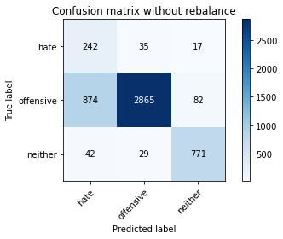

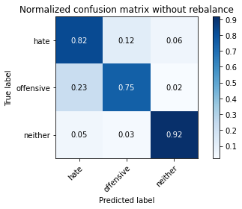

precision recall f1-score support

hate 0.21 0.82 0.33 294

offensive 0.98 0.75 0.85 3821

neither 0.89 0.92 0.90 842

accuracy 0.78 4957

macro avg 0.69 0.83 0.69 4957

weighted avg 0.92 0.78 0.83 4957

average eval_loss: 0.484822977300497, accuracy: 0.7823280209804317

training 3 epoch...

58.20317602157593 seconds used......

3 training finished! average train loss: 0.29650913943585594

evaluating...

Confusion matrix, without normalization

[[ 232 47 15]

[ 696 3038 87]

[ 61 22 759]]

Normalized confusion matrix

[[0.78911565 0.15986395 0.05102041]

[0.18215127 0.79507982 0.02276891]

[0.07244656 0.02612827 0.90142518]]

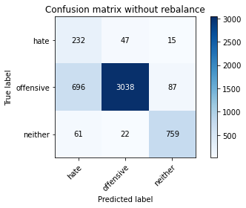

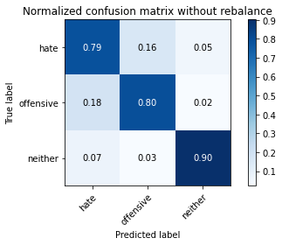

precision recall f1-score support

hate 0.23 0.79 0.36 294

offensive 0.98 0.80 0.88 3821

neither 0.88 0.90 0.89 842

accuracy 0.81 4957

macro avg 0.70 0.83 0.71 4957

weighted avg 0.92 0.81 0.85 4957

average eval_loss: 0.47562710266684116, accuracy: 0.8127899939479524

training 4 epoch...

57.93726110458374 seconds used......

4 training finished! average train loss: 0.17620072102484605

evaluating...

Confusion matrix, without normalization

[[ 215 58 21]

[ 647 3049 125]

[ 33 29 780]]

Normalized confusion matrix

[[0.73129252 0.19727891 0.07142857]

[0.1693274 0.79795865 0.03271395]

[0.0391924 0.03444181 0.9263658 ]]

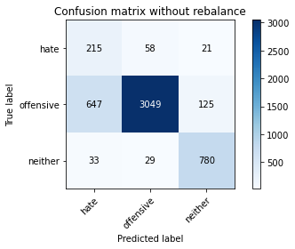

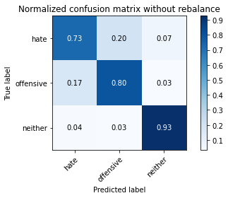

precision recall f1-score support

hate 0.24 0.73 0.36 294

offensive 0.97 0.80 0.88 3821

neither 0.84 0.93 0.88 842

accuracy 0.82 4957

macro avg 0.68 0.82 0.71 4957

weighted avg 0.91 0.82 0.85 4957

average eval_loss: 0.5106961034924873, accuracy: 0.815816017752673

training 5 epoch...

58.19213604927063 seconds used......

5 training finished! average train loss: 0.11758475624466021

evaluating...

Confusion matrix, without normalization

[[ 222 63 9]

[ 660 3091 70]

[ 52 81 709]]

Normalized confusion matrix

[[0.75510204 0.21428571 0.03061224]

[0.17272965 0.80895054 0.01831981]

[0.06175772 0.09619952 0.84204276]]

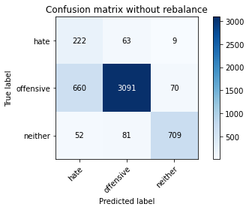

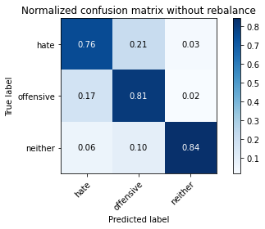

precision recall f1-score support

hate 0.24 0.76 0.36 294

offensive 0.96 0.81 0.88 3821

neither 0.90 0.84 0.87 842

accuracy 0.81 4957

macro avg 0.70 0.80 0.70 4957

weighted avg 0.90 0.81 0.84 4957

average eval_loss: 0.5444952940844067, accuracy: 0.8113778495057494

training 6 epoch...

58.13447308540344 seconds used......

6 training finished! average train loss: 0.056330360475265864

evaluating...

Confusion matrix, without normalization

[[ 224 57 13]

[ 626 3106 89]

[ 58 30 754]]

Normalized confusion matrix

[[0.76190476 0.19387755 0.04421769]

[0.16383146 0.81287621 0.02329233]

[0.06888361 0.03562945 0.89548694]]

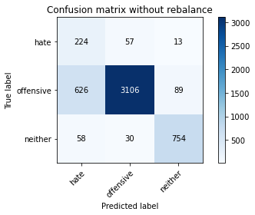

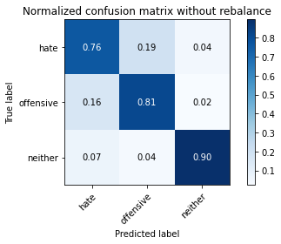

precision recall f1-score support

hate 0.25 0.76 0.37 294

offensive 0.97 0.81 0.89 3821

neither 0.88 0.90 0.89 842

accuracy 0.82 4957

macro avg 0.70 0.82 0.72 4957

weighted avg 0.91 0.82 0.86 4957

average eval_loss: 0.6897563319983878, accuracy: 0.8238854145652612

training 7 epoch...

58.23005962371826 seconds used......

7 training finished! average train loss: 0.056514785972754715

evaluating...

Confusion matrix, without normalization

[[ 230 49 15]

[ 738 2980 103]

[ 49 34 759]]

Normalized confusion matrix

[[0.78231293 0.16666667 0.05102041]

[0.19314316 0.77990055 0.02695629]

[0.05819477 0.04038005 0.90142518]]

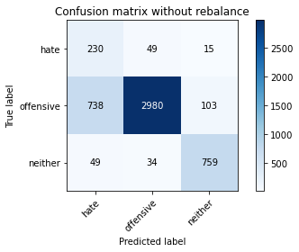

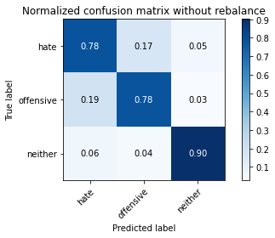

precision recall f1-score support

hate 0.23 0.78 0.35 294

offensive 0.97 0.78 0.87 3821

neither 0.87 0.90 0.88 842

accuracy 0.80 4957

macro avg 0.69 0.82 0.70 4957

weighted avg 0.91 0.80 0.84 4957

average eval_loss: 0.7490799700393935, accuracy: 0.80068589872907

training 8 epoch...

58.32837462425232 seconds used......

8 training finished! average train loss: 0.02992036574435412

evaluating...

Confusion matrix, without normalization

[[ 216 49 29]

[ 836 2844 141]

[ 26 23 793]]

Normalized confusion matrix

[[0.73469388 0.16666667 0.09863946]

[0.21879089 0.74430777 0.03690133]

[0.03087886 0.02731591 0.94180523]]

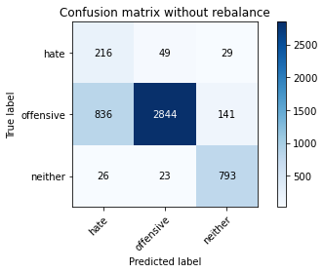

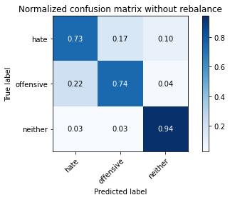

precision recall f1-score support

hate 0.20 0.73 0.31 294

offensive 0.98 0.74 0.84 3821

neither 0.82 0.94 0.88 842

accuracy 0.78 4957

macro avg 0.67 0.81 0.68 4957

weighted avg 0.90 0.78 0.82 4957

average eval_loss: 1.0668843766101819, accuracy: 0.777284647972564

training 9 epoch...

57.89397978782654 seconds used......

9 training finished! average train loss: 0.02939041612568728

evaluating...

Confusion matrix, without normalization

[[ 243 42 9]

[ 920 2825 76]

[ 64 42 736]]

Normalized confusion matrix

[[0.82653061 0.14285714 0.03061224]

[0.24077467 0.73933525 0.01989008]

[0.0760095 0.04988124 0.87410926]]

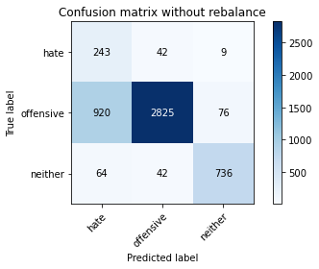

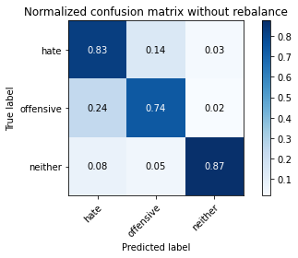

precision recall f1-score support

hate 0.20 0.83 0.32 294

offensive 0.97 0.74 0.84 3821

neither 0.90 0.87 0.89 842

accuracy 0.77 4957

macro avg 0.69 0.81 0.68 4957

weighted avg 0.91 0.77 0.82 4957

average eval_loss: 1.05366277417908, accuracy: 0.7673996368771434

training 10 epoch...

58.21570014953613 seconds used......

10 training finished! average train loss: 0.01945158267616327

evaluating...

Confusion matrix, without normalization

[[ 237 41 16]

[ 987 2726 108]

[ 60 20 762]]

Normalized confusion matrix

[[0.80612245 0.13945578 0.05442177]

[0.25830934 0.7134258 0.02826485]

[0.07125891 0.02375297 0.90498812]]

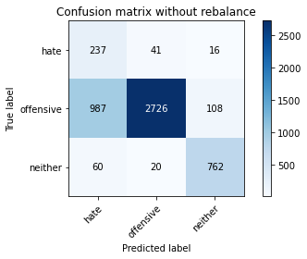

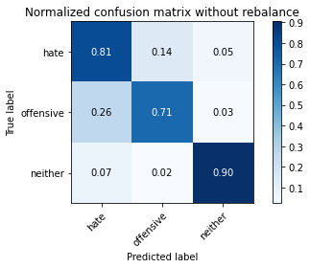

precision recall f1-score support

hate 0.18 0.81 0.30 294

offensive 0.98 0.71 0.83 3821

neither 0.86 0.90 0.88 842

accuracy 0.75 4957

macro avg 0.67 0.81 0.67 4957

weighted avg 0.91 0.75 0.80 4957

average eval_loss: 1.3511455814069941, accuracy: 0.7514625781722816